Stacey Howell
Doctor Carolyn Holloway
English 2010-046
July 22, 2013
Steps to Improve High School Learning: A Teacher’s Perspective
Vanessa is the kind of teacher that I would have wanted in high school. She is so passionate about teaching and exudes intelligence and friendliness. She was nice enough to sit down with me at my home and give me her opinion about high school preparation for the real world. Vanessa is currently pursuing her degree in Secondary Education, so it was a great experience for me to get her input since she is a student and a teacher in a way.
The main thing that I wanted to know was whether she believed that high school students are getting the proper education in order to succeed in adult life after high school, or if she believed public schools fall short on preparing students for the real world. “High school does do a good job preparing students for college, but it’s harder to say that about [high school graduates] that decide not to go to college”, she says. She went on to explain that the State Board of Education works hard to assure that teachers cover pertinent topics for the standardized tests such as the ACT and SAT tests. These tests that contain the common core are kept up to standards and are subject to peer review by professors, research scientists, and secondary school teachers to validate the material in the state tests (USBE).
Vanessa also believes that success rates greatly depend on the teacher. “I want to be the kind of teacher that connects to my students by relating the topics I’m teaching to everyday life”, she says. It’s not often that I see someone so passionate about a career. She truly wants to help individuals succeed and I can tell by her explanation of connecting to students that she wants her future students to succeed in life, and not just on their tests. Students often ask “When will I ever use this information?”, but Vanessa has an amazing capability to name a situation, career, time, or place that students will use information in topics such as Algebra, World History, and English. “The only way my students will be interested in a word I have to say is if I can relate it to their life”. She has a good point, since roughly 75 percent of elementary school students (grades 5 and 6) are actively involved and invested in school, compared with only 44 percent of high school students (grades 9 through 12) (Sheehy). I can’t help but admire her for teaching students how to apply what seems like irrelevant topics to life outside of high school – this is a huge aspect of preparing our youth for their future.
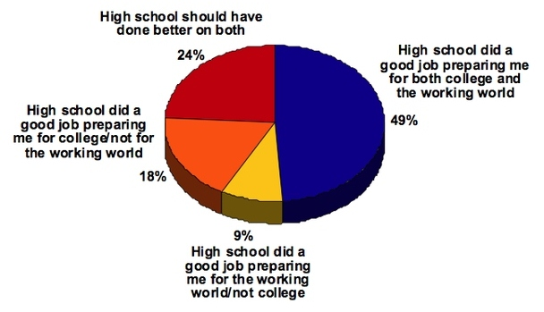
Survey of 1,507 high school graduates of 2010
Source: The Atlantic Wire
http://www.theatlanticwire.com/national/2011/09/only-half-high-school-grads-feel-prepared-college-and-work/42019/
I had to share my high school experience with her; I feel like I didn’t learn anything about personal finances such as credit scores, how loans work, and the importance of paying our bills. Vanessa agreed that there should be more emphasis on personal finances and adult roles. “The core curriculum is so important, but I think it would be more effective to start teaching them at an earlier age, like in elementary school. That would leave more time for high school to teach students more about real life skills.” Public high schools eliminated many electives after the No Child Left Behind law in 2001, to focus on bringing all students up to minimum federal and state standards (Hu). Although she mentioned that the public school system is successful at preparing high school students for college, she does say that she would like to see more classes that prepare students for life outside of school. “It would be nice to see more classes like business and apprenticeship programs. I’d also like to see more hands-on approaches – like guest speakers and field trips to apply knowledge gained in the classroom”, she explains.
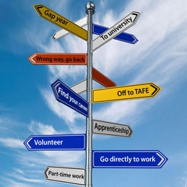
I felt like I gained another insight from a person who is very knowledgeable and passionate about teaching. Vanessa explained why and how public high school prepares students for college with a good system through the State Board of Education. Although she believes in the public schools system, I think it’s agreeable that the public school system could use more classes that prepare students for life outside of school. Classes that apply to the workforce, finance, and other mediums of knowledge such as speakers and field trips could be even more beneficial to students, because they are not only intellectual but also social and emotional beings, and all these dimensions interact to impact learning and performance (CMU). Vanessa’s attitude and character speaks volumes about what a great teacher she’ll be, and I am very happy that I had the opportunity to gain some insight from a future teacher and a student.
Source: Career FAQs
http://www.careerfaqs.com.au/courses/study-tips/now-what-life-after-high-school/

Works Cited
CMU (Carnegie Mellon University). "Who Your Students Are." Carnegie Mellon: Eberly
Center. 2010.Web. 18 Jul 2013. <http://www.cmu.edu/teaching/designteach/design/yourstudents.html>.
Hu, Winnie. "High Schools Add Electives to Cultivate Interests." The New York Times. 26 Oct 2008. Web. 18 Jul 2013. <http://www.nytimes.com/2008/10/27/education/27electives.html?pagewanted=all&_r=1&>.
Sheehy, Kelsey. "Student Engagement Nosedives in High School." US News. 16 Jan 2013. Web. 18 Jul 2013. <http://www.usnews.com/education/blogs/high-school-notes/2013/01/16/student-engagement-nosedives-in-high-school>.
USBE (Utah State Board of Education). "Common Core and the Utah Education Transformation Plan." Utah State Office of Education. 08 Jun 2013. Web. 18 Jul 2013. <http://www.schools.utah.gov/board/Common-Core.aspx>

