Stacey Howell

English 2010-046

Doctor Carolyn Holloway

August 2, 2013

References

Ghahremani, Yasmin. http://www.foxbusiness.com/personal-finance/2012/03/09/public-schools-get-mixed-grades-on-financial-literacy/

Partridge, Stephanie. http://www.more4kids.info/2286/parenting-and-teen-independence/

Figure 1 http://www.pennlive.com/editorials/index.ssf/2011/05/theres_no_magic_bullet_to_impr.html

Figure 2

http://www.theatlanticwire.com/national/2011/09/only-half-high-school-grads-feel-prepared-college-and-work/42019/

Figure 3

http://www.everydaylanguagelearner.com/2012/01/30/language-learning-tip-use-music-learn-foreign-language/

### Brightening Our Future Generation

It is extremely important that our future generation comes out of high school ready for the real world and ready to start their adult life successfully. Our public schools need to continue providing the fundamentals and common core of education; however it will make a significant difference to implement mandatory life-skills and career-readiness courses – along with more available mediums of teaching that students can identify with and gain experience from. Let’s get our high school students to 100% readiness for life after high school.

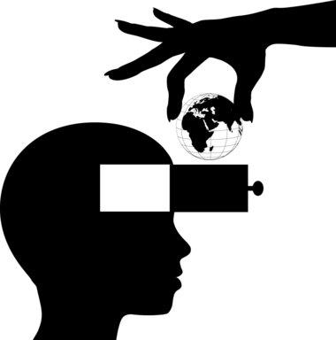

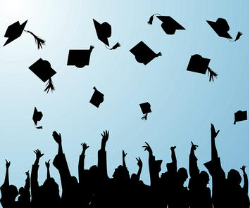

# Improving Education for Real World Preparation

## By Stacey Howell

Figure 3

Figure 2

**Get Involved!**

Get information and use your voice to improve our public education at http://www.schools.utah.gov/board/ and www.parents4publicschools.com.

**More Beneficial Mediums of Teaching**

Acquiring more mediums of knowledge would be extremely beneficial for students such as **guest speakers** – professionals in their field, **hands-on training**, and **field trips** to educational facilities

When students are brought into an environment where they can gain hands-on experiences and learn from others who are not necessarily our school teachers, they gain a greater insight and appreciation for learning.

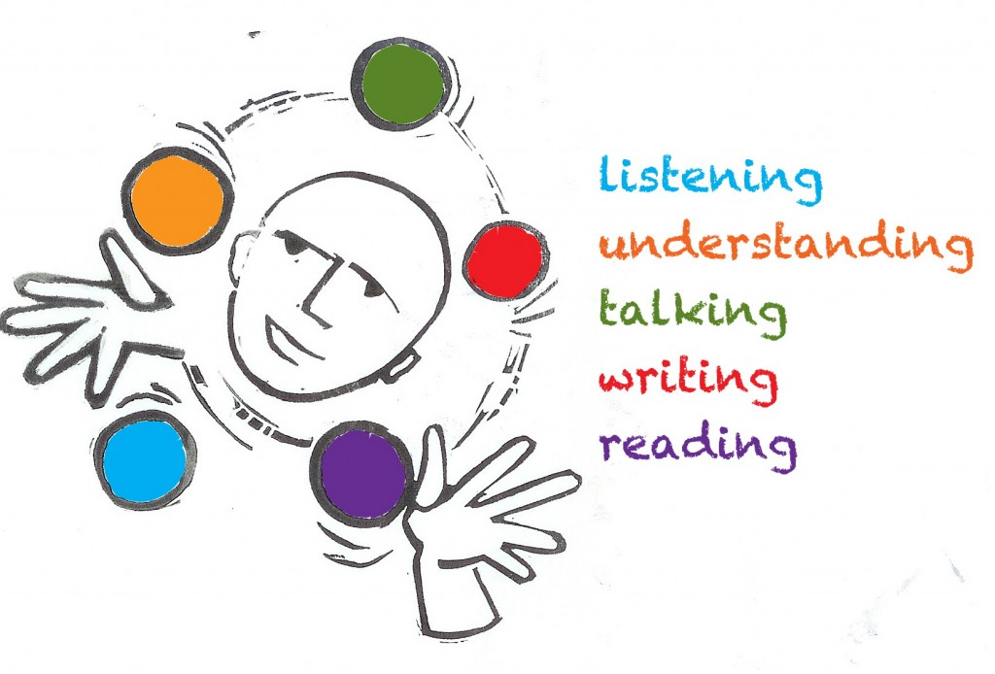

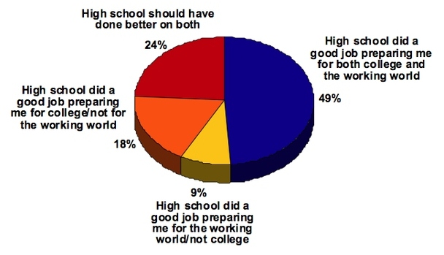

Public education in America is falling short when it comes to evolving with modern American society. Our youth is required to learn basic textbook knowledge, but they do not acquire practical knowledge and skills to succeed in the real world. Passing a state-standardized test in math, language, and science is not exactly the kind of knowledge that it takes for students to come out of high school ready for the real world and ready to start their adult life – whether it’s heading straight into the workforce, going to college, or starting a family.

### Life After High School

**What do we need to implement?**

The average high school student must take core curriculum classes in order to graduate with a high school diploma and get into college:

* English Literacy
* Mathematics
* Science
* Social Studies
* Foreign Language

However, we need more mandatory classes that teach practical skills for life after graduation. For example:

* **Personal Finance** – this class is a requirement in only 4 states. Students need to learn to manage money, loans, and credit scores.
* **Career Readiness** – It is necessary for students to know how to write a resume and maintain a job. It would be extremely beneficial to gain hands-on experience.
* **Adult Roles** – To teach students about life after high school and how to become a self-dependent person.